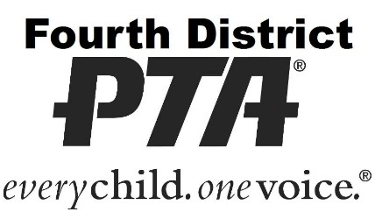

**High School Senior**

**Voter Registration Drive**

In support of civic engagement in Orange County – 2018-19

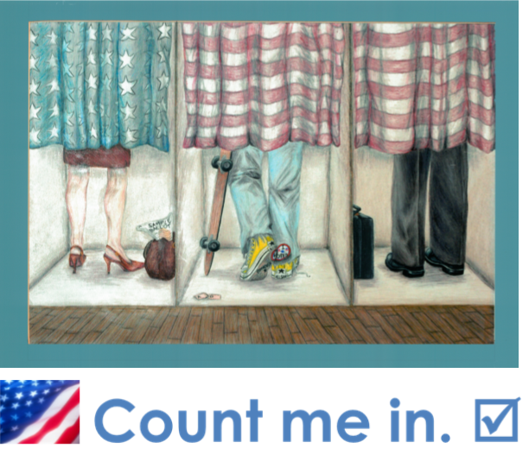

# Program Overview

**Background**

By the end of their senior school year, students will be prepared to enter the adult world of attending a college or university, obtaining a career, and engaging in the broader community. One of the most important ways they will contribute to their community is to become an informed citizen and exercise their right to vote. In California, 16-year-olds and 17-year-olds can pre-register to vote. By pre-registering, California youth will have their voter registration become active automatically when they turn 18. In Orange County, pre-registered youth will also receive a postcard confirmation from the OC Registrar upon their 18th birthday.

*PTA believes that education in California isn’t just about preparing our children for college and careers – we must also teach our children how to be responsible citizens in a democracy.*

Fourth District PTA provides leadership for all of the school and local council PTAs/PTSAs in Orange and southeast L.A. Counties, representing over 120,000 members and 500,000 public school students. As part of its advocacy focus on supporting civic engagement, the Fourth District PTA Advocacy Team developed a county-wide high school senior voter registration drive in partnership with Orange County Registrar of Voters Neal Kelley and Orange County Superintendent of Schools Al Mijares, Ph.D.

**The Pilot**

With the help of voter registration materials and resources provided by the Orange County Registrar of Voters and the California Secretary of State, a pilot program was launched at Laguna Beach High School – Orange County’s smallest high school – at the start of the spring semester and the beginning of the 2016 election year. PTA volunteers assembled and distributed voter registration packets to each Laguna Beach High School senior in their U.S. Government / Economics class, because it is a required class for virtually all 12th-grade students.

The packets consisted of a large envelope featuring our “Count Me In” theme that contained a paper voter registration form that can be returned by mail, a voter registration slip with a QR code that can be scanned by a smartphone to register electronically, the publication “When You Turn 18: A Survival Guide for Teenagers” produced by the State Bar of California that addresses the legal rights and responsibilities of 18-year-olds, and a cover letter signed by OC Superintendent Dr. Al Mijares, OC Registrar Neal Kelley, and our regional Fourth District PTA President (at the time) Bev Berryman. Among other things, the letter notes how to obtain dependable voter information and how to learn about voting options (such as vote-by-mail or finding one’s polling place for Election Day) from the OC Registrar of Voters.

The packets were delivered to the teachers’ classrooms along with a letter of explanation and a “Register. Volunteer. Vote!” pamphlet produced by the OC Registrar. Voter registration form display stands with additional forms were posted in the school library and the student activities office. To meet demographic needs, voter registration forms and the “When You Turn 18” guides were furnished in both English and Spanish.

Teachers who helped distribute the voter registration packets also incorporated it into the lesson for the day, facilitating class discussions with students about voting, the right to vote, and use of the absentee ballot for students who attend a college or university away from home. The school district issued a press release in support of the effort. At the school’s monthly PTA meeting, there were several positive comments from parents who said that their kids were very excited about registering (yes – the teens actually went home and talked about it!). Many of the 17-year-olds didn’t realize before this that they could register in advance to ensure their ability to vote in their first election. Remarkably, one parent even used the packet to register himself to vote, too – for the first time!

**Results**

The response was very positive and enthusiastic. Having both our county school superintendent and Neal Kelley himself (who addressed PTA members during advocacy training) involved as partners in this endeavor helped to give the project the credibility it needed to ensure broad support. For the Laguna Beach pilot, the LB PTA Council, Laguna Beach Unified School District Superintendent Sherine Smith, and LBHS Principal Chris Herzfeld all embraced the civic engagement program. The story was featured on the front page of the *Orange County Register*, and the pilot won the CAPTA Spotlight award for council advocacy.

Here are comments received from three teachers involved in the pilot:

*Thanks for leading this. I definitely feel it empowered the students. Many have said that they are excited to vote and that they will be voting in the primary. As each day unfolds towards the primary, I have noticed an excitement in the kids that I don't recall from past elections. Some of the enthusiasm is of course from the colorful candidates, but the fact that they are now empowered to vote has definitely added to their motivation. Again, thank you for organizing this.*

*The group I have now for Econ, I had for Government in the fall. What’s been nice is to be able to keep going back and forth between the two subject matters with the same group since they are linked. I passed out the materials to the group and again impressed upon them what it means to have the right to vote. I spent some time sharing with them my own first chance to vote and how cool I thought I was. We stay up to date with the current polls as well as debates which in some cases gets the students pretty fired up.*

*I sent my students home with the packets before break. We had a great discussion about voting, the right to vote in primaries based on what party they choose, and the absentee ballot (if they are going to school away from home). The materials make it easy. They were pretty excited...I think the privileges that come with being 18 are just sinking in!*

The goal of the program has been to reach every public high school senior in Orange County. Closer to the June election, we followed up with students electronically about important dates and the value of being a well-informed voter utilizing resources from the OC Registrar of Voters and the League of Women Voters. **Results as of the June 2016 election showed that registration of OC’s 18-year-olds was up 41% from the June 2012 election, and almost doubled from the June 2014 election.** In subsequent years, the program has continued and grown throughout the county. Join us in this important effort!

***Thank you for your participation and leadership!***

*– Kathleen Fay*

*Fourth District PTA Advocacy Team*

*2018-19*

# TO BEGIN: Approve Your Program

## Make a motion to approve

First of all, you need to make a motion at your PTA Council meeting to approve your voter registration drive. Ask your Council President to put the item on the agenda and provide an overview in advance.

Sample motion:

*“I move to have Council support a district-wide voter registration drive that would include all high school seniors, in addition to parents and staff, and to work in cooperation with our administrators, the OC Registrar of Voters, Fourth District PTA, and the unit PTAs, with additional resources provided by the California Bar, to promote civic engagement in our community.”*

## Secure administration support

If your high school principals and school district superintendent do not attend your PTA Council meetings, then work with your Council President to obtain their support for the program, noting that it has already been approved for local implementation by:

* Your own PTA Council
* Fourth District PTA
* The Orange County Registrar of Voters, Neal Kelley
* The Orange County Superintendent of Schools, Dr. Al Mijares

Additionally, California Secretary of State Alex Padilla was pleased to learn about our program and said he was happy to hear that we’re finding the voter registration materials and improved online access that his office developed to be helpful in our efforts. This should put administrators’ minds at ease about participating!

## Bring in the schools

**PTA**

Engage your high school PTA president and unit advocate in the effort to gather volunteers to compile and distribute materials. If needed, create a line item in the unit budget for supplies.

**Teachers**

If your high school U.S. Government / Economics teachers need some ideas for what to incorporate into their lessons when the packets are distributed, here are some suggestions:

* Eighteen-year-olds could not vote before the Twenty-sixth Amendment (Amendment XXVI) to the US Constitution became law in 1971. It was primarily students who led the effort to lower the voting age from 21 to 18 during the Vietnam War in the 1960s, to ensure that youth had a voice in matters that affected them directly.
* Having a knowledgeable electorate is the foundation of our democracy. Instruct kids on how to become an informed voter by depending upon reliable information sources to become familiar with the issues before the elections.
* Discuss new rights and responsibilities of a legal adult.
* Follow current election events, and get students to voice their own opinions about the process.
* Address primary voting and political party affiliation.
* Remind them about using absentee ballots if going to college away from home.
* Tell what it was like the first time you voted.

# Gather Materials

## Get a count

To begin, go to your high school’s registrar and request the names and room numbers of the teachers leading the current U.S. Government / Economics classes, and the total number of students in each class.

## Voter Registration Forms

**How to obtain**

The office of the Orange County Registrar of Voters in Santa Ana will be happy to provide you with all of the California Voter Registration Forms you’ll need. These are forms that can be folded and mailed back to the Registrar of Voters, no postage necessary. PTAs do NOT collect and turn in the forms themselves, nor do we assist in completing the forms – we only distribute them.

Forms are available in:

* English Only
* English/Chinese
* English/Korean
* English/Spanish
* English/Vietnamese

The combination forms contain both languages listed, and so are usually most convenient.

To obtain the quantity of forms needed, you must complete a “VOTER REGISTRATION CARD STATEMENT OF DISTRIBUTION PLANS” while on premises at the Registrar’s office (they have the forms there). Be sure to indicate that you will NOT be collecting affidavits of registration.

ORANGE COUNTY REGISTRAR OF VOTERS

1300 South Grand Avenue, Building C, Santa Ana CA 92705; 714.567.7600

(At the corner of Grand Avenue and McFadden)

Office Hours are 8 a.m. - 5 p.m. Monday through Friday, except holidays

**Additional materials**

Upon request, the Registrar will also furnish you with:

* “Register. Volunteer. Vote!” pamphlets that are useful for your teachers
* Display stands for voter registration forms (school library, student activities office, front desk)

***Electronic Alternative:***

If your high school cannot support distribution of paper forms, or if you want to follow up electronically, you can conduct a campaign using email and/or your website! You can use these hyperlinks:

**Register to vote online!**

Orange County Registrar of Voters: **Online voter registration**

[**ocvote.com**](http://www.ocvote.com)

[](http://www.ocvote.com)

## Information for new adults

The State Bar of California produces the publication “When You Turn 18: A Survival Guide for Teenagers” that addresses the legal rights and responsibilities of 18-year-olds. This makes a great handout (if you get it printed); it addresses a number of issues important to young adults, including information about laws related to:

* alcohol
* banking
* contracts
* credit
* employment
* hate crimes
* the Internet
* jury duty
* military service
* voting

You can use these hyperlinks in your emails and/or your website – available online (PDF) in both English and Spanish:

**Laws that affect 18-year-olds.**

State Bar of California info: ***When You Turn 18: A Survival Guide for Teenagers***

[www.calbar.ca.gov/Portals/0/documents/ConsumerInformation/2014_18_English_2014-R.pdf](http://www.calbar.ca.gov/Portals/0/documents/ConsumerInformation/2014_18_English_2014-R.pdf)

[](http://www.calbar.ca.gov/Portals/0/documents/ConsumerInformation/2014_18_English_2014-R.pdf)

## Let kids register to vote on their smartphones

You can use voter registration slips that contain a QR code that can be scanned by a smartphone to register electronically. Use this link to download a printable flyer (PDF) that contains a QR code – kids use a [free] phone app to scan the code that goes to the voter registration site. PTAs can print 4-to-a-page and include in packages, or offer in the school library, student activity center, and front desk.

[**Online Voter Registration Flyer (PDF)**](http://elections.cdn.sos.ca.gov/outreach/posters/Reg-Day-Flyer-Final-4.pdf) – handouts

<http://elections.cdn.sos.ca.gov//outreach/posters/reg-day-flyer-final-4.pdf>

[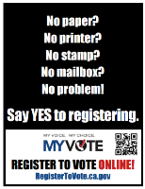](http://elections.cdn.sos.ca.gov/outreach/posters/reg-day-flyer-final-4.pdf)

## Create a cover letter for the teachers

You’ll need to assemble enough voter registration packages to distribute to each senior in his/her U.S. Government / Economics class. On the next page is a sample cover letter that can be adapted for use at your school to accompany the set of packets to be distributed by each teacher. (Their principal will already have discussed this with them, if you’ve gotten everyone’s cooperation as discussed.)



***COVER LETTER TO TEACHERS***

Replace filler names and info with your own, and delete this text box.

**Sunshine Council of PTAs**

125 First Street

Your Town, CA 90000

September 8, 2018

Dear OCHS U.S. Government/Economics Teachers:

Sunshine PTA, in partnership with the Orange County Registrar of Voters, the Orange County Department of Education, and OC’s Fourth District PTA, have put together these voter registration packets to be distributed to each high school senior in their U.S. Government/Economics class. This voter registration drive was approved at our PTA Council meetings attended by Principal John Smith and Superintendent Jane Doe, and is part of a county-wide effort that was successfully piloted in Laguna Beach then adopted by PTAs across OC.

By the end of this school year, students will be prepared to enter the adult world of college, career, and community. When they turn 18, they will be able to exercise their most important right as an American citizen: the right to vote. As a teacher, you know that having a knowledgeable electorate with robust participation is the foundation of our democracy. Thank you for supporting this effort as a natural extension of your daily teaching!

Sincerely,

**- Alice Birney**

**SUNSHINE PTA COUNCIL ADVOCATE**

   949-555-1212 home / [PTA@web.net](mailto:PTA@web.net) / 949-555-6789 cell/text

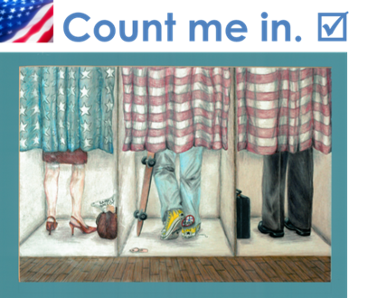

## Cover letter for students

To illustrate the support of the broader community for this effort, the student voter registration packets go out with a cover letter signed by:

* Orange County Superintendent of Schools Dr. Al Mijares
* Orange County Registrar of Voters Neal Kelley
* Regional Fourth District PTA President Erin Jenks

It has been scanned as an image onto the next page. (PTAs may want to copy these in color, if facilities are available to do so.)

***Electronic Alternative:***

If your high school wants to offer your voter registration drive electronically, on the page after that is the original (unsigned) document which you can also utilize for your email campaign (includes hyperlinks). Note that the text of the cover letter to students is phrased as to allow the letter to be included in a physical package OR sent to students electronically, so that they can just utilize the hyperlinks contained in the letter.

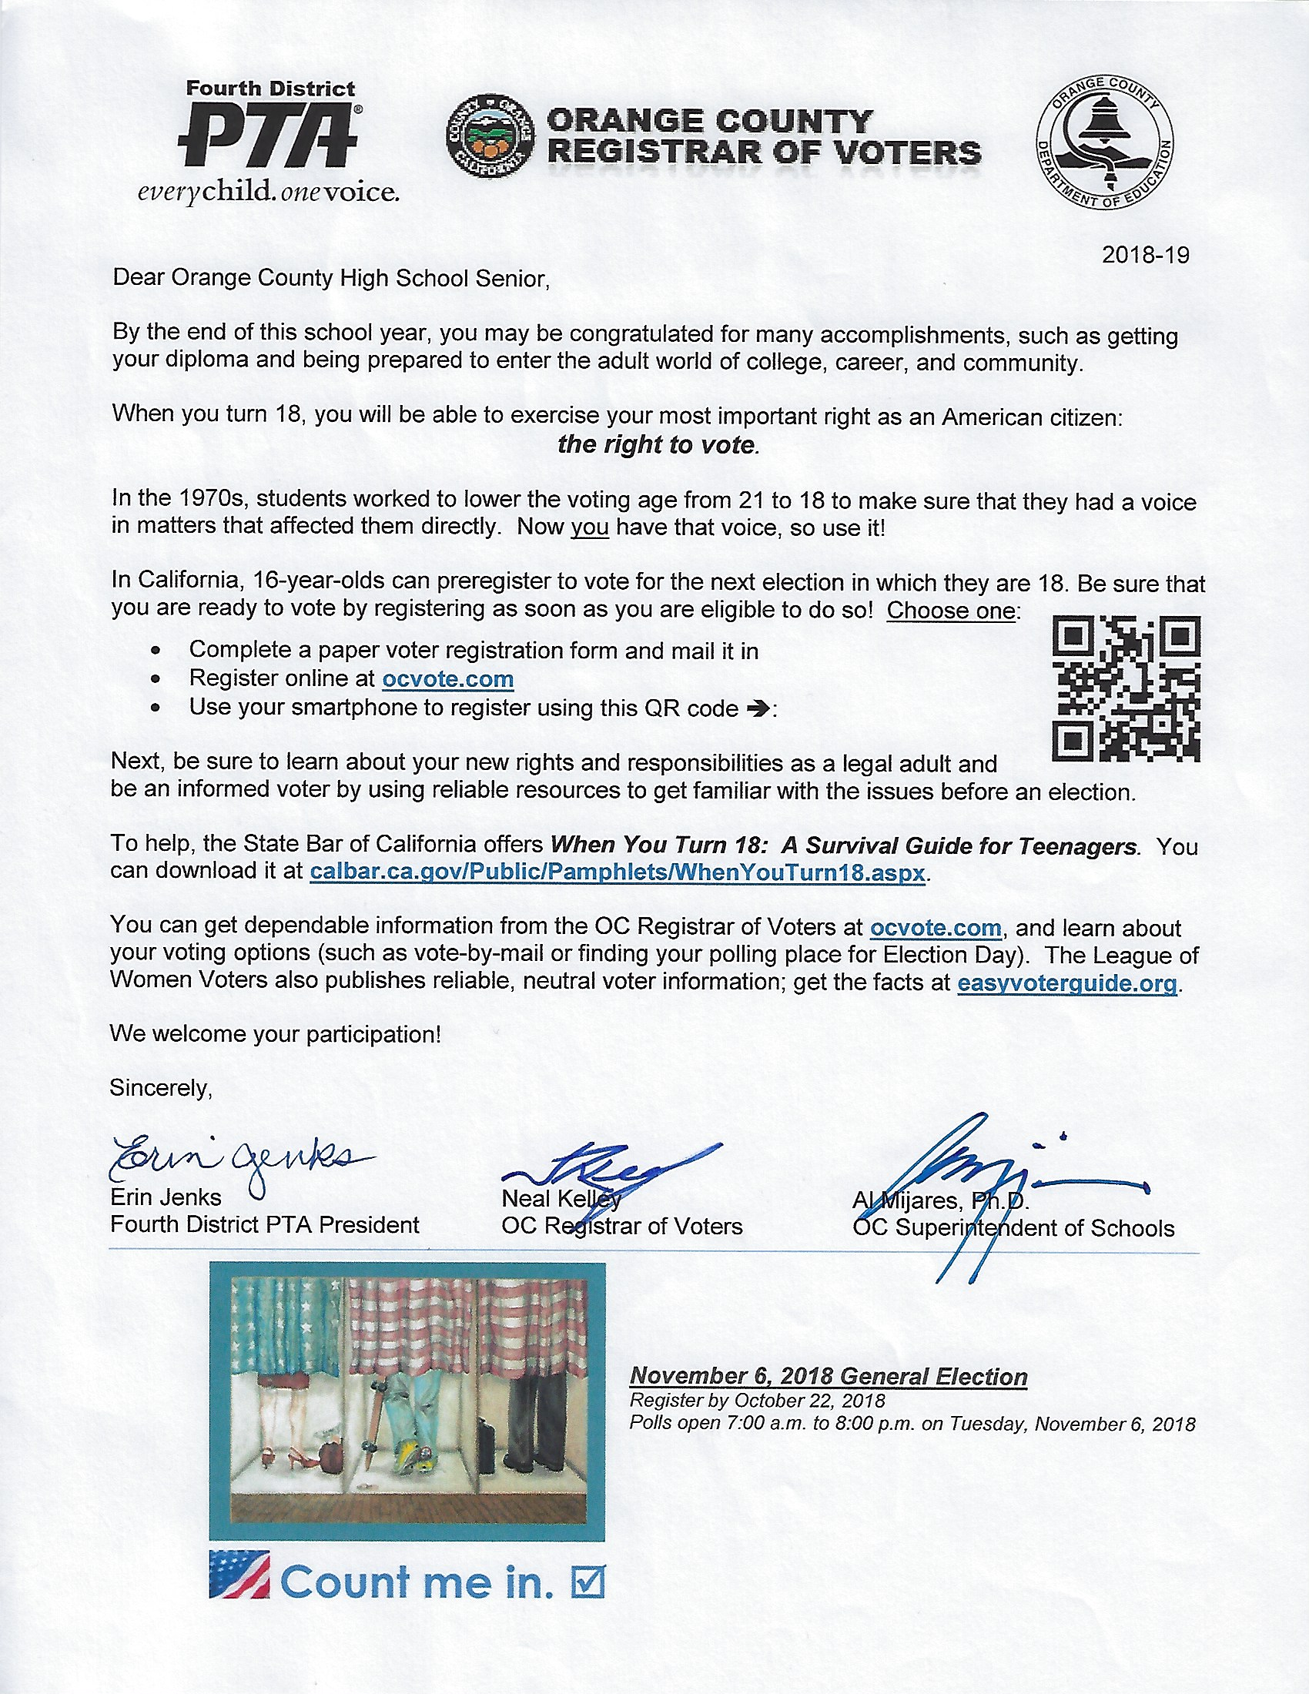

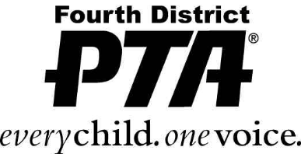 

2018-19

Dear Orange County High School Senior,

By the end of this school year, you may be congratulated for many accomplishments, such as getting your diploma and being prepared to enter the adult world of college, career, and community.

When you turn 18, you will be able to exercise your most important right as an American citizen:

***the right to vote****.*

In the 1970s, students worked to lower the voting age from 21 to 18 to make sure that they had a voice in matters that affected them directly. Now you have that voice, so use it!

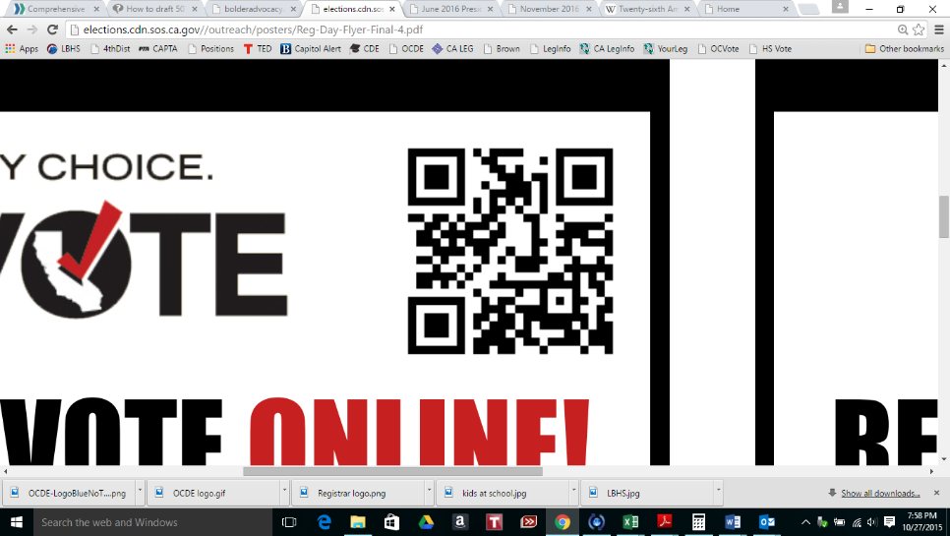In California, 16-year-olds can preregister to vote for the next election in which they are 18. Be sure that you are ready to vote by registering as soon as you are eligible to do so! Choose one:

* Complete a paper voter registration form and mail it in
* Register online at [**ocvote.com**](http://www.ocvote.com)
* Use your smartphone to register using this QR code 🢂:

Next, be sure to learn about your new rights and responsibilities as a legal adult and be an informed voter by using reliable resources to get familiar with the issues before an election.

To help, the State Bar of California offers ***When You Turn 18:*  *A Survival Guide for Teenagers****.* You can download it at [**calbar.ca.gov/Public/Pamphlets/WhenYouTurn18.aspx**](http://calbar.ca.gov/Public/Pamphlets/WhenYouTurn18.aspx).

You can get dependable information from the OC Registrar of Voters at [**ocvote.com**](http://www.ocvote.com), and learn about your voting options (such as vote-by-mail or finding your polling place for Election Day). The League of Women Voters also publishes reliable, neutral voter information; get the facts at [**easyvoterguide.org**](http://www.easyvoterguide.org/).

We welcome your participation!

Sincerely,

|  |  |  |
| --- | --- | --- |
| Erin Jenks | Neal Kelley | Al Mijares, Ph.D. |
| Fourth District PTA President | OC Registrar of Voters | OC Superintendent of Schools |

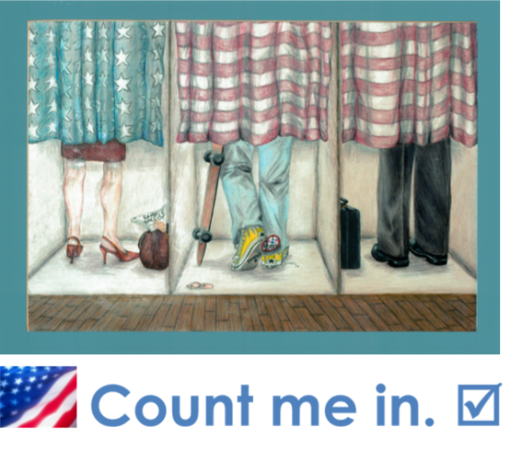

***November 6, 2018 General Election***

*Register by October 22, 2018*

*Polls open 7:00 a.m. to 8:00 p.m. on Tuesday, November 6, 2018*

# Assemble your packages

Assembly is best done on-site – ideally in a conference room or large workspace. Be sure to reserve the space in advance with the office staff. The pilot school utilized PTA volunteers to assemble physical voter registration packets that had paper clipped together:

* The **cover letter** signed by OC Superintendent of Schools Dr. Al Mijares, OC Registrar of Voters Neal Kelley, and Fourth District PTA President Erin Jenks
* A paper **voter registration form** that can be returned by mail (folded to fit)
* A voter registration **slip with a QR code** that can be scanned by a smartphone to register electronically
* The publication “**When You Turn 18**: A Survival Guide for Teenagers” produced by the State Bar of California that addresses the legal rights and responsibilities of 18-year-olds

These packets were inserted into 9x12 envelopes, and each envelope had an adhesive label affixed to the front with the “Count me in” theme and the name of the sponsoring PTA Council. These were printed in color, six-to-a-page, onto label sheets compatible with Avery 5164/8164. Sample template is on the next page; replace the Council name with your own. You may need to adjust the margins for your own printer (it is its own section of the document).

**Suggested supply list**

(*adjust as needed to meet the needs of your own school)*

* List of teachers, room #s, and class counts for U.S. Government / Economics classes
* 9x12 Envelopes and adhesive labels (optional)
* Large paperclips
* Cover letter to students
* California Voter Registration Forms
* Voter registration slip with QR code
* “When You Turn 18” publication (optional – may be furnished electronically)
* Cover letter for teachers
* Boxes / carts for transport

|  |  |  |
| --- | --- | --- |
| LAGUNA BEACH UNIFIED COUNCIL OF PTAs  **Voter Registration 2018** |  | LAGUNA BEACH UNIFIED COUNCIL OF PTAs  **Voter Registration 2018** |
| LAGUNA BEACH UNIFIED COUNCIL OF PTAs  **Voter Registration 2018** |  | LAGUNA BEACH UNIFIED COUNCIL OF PTAs  **Voter Registration 2018** |
| LAGUNA BEACH UNIFIED COUNCIL OF PTAs  **Voter Registration 2018** |  | LAGUNA BEACH UNIFIED COUNCIL OF PTAs  **Voter Registration 2018** |

# Distribute registration packages

## Prepare for delivery

Make arrangements to borrow a cargo or library cart to do this. Boxes help. Give each U.S. Government / Economics teacher enough for all of his/her classes, and top with the cover letter as a reminder. Send your teachers an email to let them know the delivery is coming so that they can make room for the packages in the classroom.

## Deliver envelopes to classrooms

This can either be done by the PTA volunteers or by designated students, depending on which is preferred by your administrator. Delivering the packages just after the school day ends helps to minimize disruption.

# Communicate

## Update your members

Report back to your PTA leaders and members at meetings. Be sure to include an article in your own PTA newsletter, or send out a special e-blast about it. If possible, give a short update to your school board as well. If you use social media, post it.

## Issue a press release

With your superintendent’s support, it’s a courtesy to the school district to invite their public relations or communications staff to work with you to issue a press release. As district employees, they are also likely to be able to secure, or have on file, releases so that relevant photos may be taken in class, as well as getting quotes from teachers and administrators. Alternatively, you can issue a press release about your efforts to the most local media in your area, with approval of your PTA president. A sample to give you an idea about what to include in a press release is included at the end of this packet. For tips see the California State PTA *Toolkit:* [*http://toolkit.capta.org/running-your-pta/communications/publicizing-pta-to-the-larger-community/*](http://toolkit.capta.org/running-your-pta/communications/publicizing-pta-to-the-larger-community/)*.*

## Get feedback

Ask the teachers how it went, and let them offer suggestions for improving the program. Later, send out a survey to seniors to find out if they actually registered to vote (and how), if they plan to do so (and how), whether the packets helped, their thoughts on the program, and what their suggestions might be for next time. Please tell Fourth District PTA’s Advocacy Team about what they said so that we can share what you learned with others!

## Follow up

As a reminder to the high school seniors in the approach to the next election, send out an electronic notice/email:

* Electronic registration link (*above*)
* *[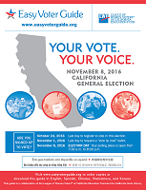](http://www.easyvoterguide.org/wp-content/uploads/2010/09/EVG-CAGeneral-Nov-8-16-Final.pdf)*Link to “When You Turn 18” (*above*)
* Note the registration deadline to vote
* Link to voter information at the Registrar of Voters website and to the League of Women Voters *Easy Voter Guide*: [www.easyvoterguide.org](http://www.easyvoterguide.org)

## Parents & staff, too!

Leverage your PTA’s efforts by offering parent and staff voter registration opportunities.

*Voter Registration Drive*

 To promote voter registration, your PTA may conduct a registration drive. This is a nonpartisan activity and it is fine to do on school district premises, with the necessary approvals.

You can encourage and promote registration by having registration forms available at the information desk in your school office or at a PTA meeting. Registration forms are available in many languages from the Orange County Registrar of Voters. Be sure to obtain forms in the languages commonly spoken in your community.

Planning a voter registration drive:

* From the Orange County Registrar of Voters:
* Obtain important deadlines and post them at school, in newsletters, on websites and social media, etc.
* Request all necessary materials.
* Use their website link to offer online voter registration via an email/electronic voter registration drive ([www.ocvote.com/registration](http://www.ocvote.com/registration)).
* Focus your registration activities in the months before the election registration deadline.
* Select times and venues where there will be a high volume of people such as: Back-To-School Night, Open House, college fairs/info nights, PTA events. Students can assist to earn volunteer hours. Complete the required facilities use forms when using any school facility.

Voter registration can be an ongoing effort:

* Combine voter registration opportunities with other PTA activities.
* Encourage voters to update their registration if they have moved.
* Include a voter registration form in new-parent packets.
* Plan an event for National Voter Registration Day – the fourth Tuesday in September.
* Create a link on your PTA website to the OC Registrar of Voters: [www.ocvote.com](http://www.ocvote.com).

**ADDITIONAL RESOURCES:** National PTA has coordinated with Nonprofit VOTE to provide voter registration tools for all PTAs. For information, go to the PTA website **pta.org**; under Advocacy, see Election Guides. Also, the California Secretary of State website has an excellent guide to running a voter registration drive at: <http://www.sos.ca.gov/elections/guides/guide-to-vr-drives.pdf>.

**FOR IMMEDIATE RELEASE**

**SAMPLE PRESS RELEASE**

Use your own info and quotes.

Send to your most local papers.

**SUNSHINE UNIFIED PTA COUNCIL**

**CONTACT: PHOEBE HEARST**

**PRESIDENT, SUNSHINE UNIFIED PTA COUNCIL**

**(949) 555-9999 EXT. 3333**

**September 15, 2017**

**PTA prompts Sunshine Hills high school seniors to register to vote**

SUNSHINE HILLS, Calif. – The Sunshine Unified PTA Council, in conjunction with the Orange County Registrar of Voters, Orange County Department of Education and Orange County/Los Angeles regional Fourth District PTA, assembled and distributed voter registration packets to each Sunshine Hills High School senior in U.S. government and economics classes this week.

By the end of this academic school year, students will be prepared to enter the adult world of attending a college or university, obtaining a career, and engaging in the broader community. One of the most important ways they will contribute to their community is to become an informed citizen and exercise their right to vote. In California, 16- and 17-year-olds can pre-register to vote.

Sunshine Hills High School participated as part of a county-wide initiative to engage high school seniors in the voter registration project.

“Insert your own quote about the project here,” said Sunshine Unified PTA Council Phoebe Hearst. “This sentence was also said.”

The voter registration packets distributed to SHHS seniors included a voter registration form to be sent via mail, a voter registration slip with a QR code that can be scanned by a smartphone to register electronically, a publication “When You Turn 18: A Survival Guide for Teenagers” produced by the State Bar of California, and a cover letter signed by the Orange County Superintendent of Schools Dr. Al Mijares, Orange County Registrar of Voters Neal Kelley, and regional PTA President Erin Jenks.

Teachers who helped distribute the voter registration packets also incorporated it into the lesson for the day. Selena Butler, SHHS government and economics teacher, did this thing to lead a class discussion about voting rights and such.

“Following our discussion, every student in one of my morning class registered via smartphone,” said Butler. “Yet in my afternoon class, where kids had drained their phone batteries texting during lunch, they filled out their paper registration forms instead.”

Alice Birney, senior in Butler’s AP government and politics course, said this about the registration packet, offering details. “Seeing all that information in writing about my responsibilities now that I’ve turned 18 was really sobering,” said Birney. “It hit home that my vote really matters. Now when I think about the elections, I say count me in!”

###