Fourth District PTA
AWARDS!

2016-2017 AWARDS FOR UNITS/COUNCILS
&
RECOGNITION FOR OUTSTANDING INDIVIDUAL SERVICE

APPLICATIONS ARE DUE ON THURSDAY, FEBRUARY 9, 2017!

★Creative UNIT Membership: for creative & successful membership campaigns
★Creative Program: for quality programs that support PTA’s mission & goals
★NEW! Outstanding Local Advocacy Award: for meaningful efforts to advocate for change
★Outstanding Unit/Council: for significant achievement in your school community
★Outstanding Administrator: for extraordinary service for children, youth and school
★Outstanding Teacher: for extraordinary service for students in school and community

Fourth District PTA Honorary Service Awards: to recognize PTA leaders’ service

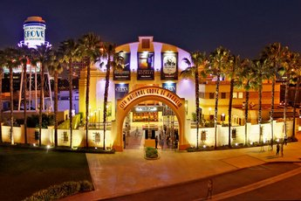
★ SAVE THE DATE★
Special awards ceremony at the
Fourth District PTA
Annual Administrators’ Dinner
THURSDAY, MARCH 9, 2017
at the
City National Grove in Anaheim

Updated information and Award Applications!
www.fourthdistrictpta.org/awards

Contact: Fran Sdao, Awards Chairperson
awards@fourthdistrictpta.org

★Honorary Service Awards Applications are due on May 11, 2017. Awards will be announced at the year-end luncheon in June 2017.

