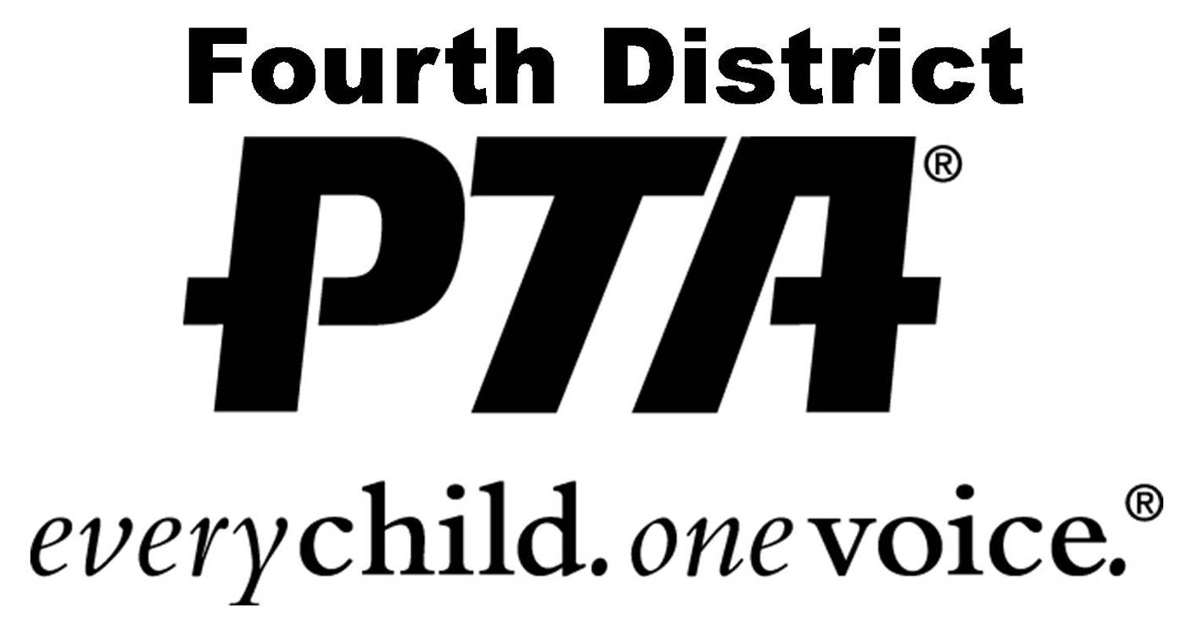
Sacramento Safari 2016

Monday, February 22 through Tuesday, February 23

MAIL-IN REGISTRATION FORM
*Use this form only if you choose not to register online*

Registration Fee: $330 per person, double occupancy; or $445 per person, single occupancy UNTIL December 18, 2015. After that, the price increases to $360 per person, double occupancy; or $475 per person, single occupancy. Includes hotel stay at Embassy Suites, lunch
& dinner on first day, breakfast & lunch on second day, plus all registration materials.
Does not include: flights, ground transportation or dinner the second day.

Registration Deadline: January 29, 2016 or when all available places are filled. (Limit of 100).

Payment Details: Make check payable to: Fourth District PTA. Then mail along with the completed registration form below to:
Fourth District PTA, 1520 Brookhollow Drive, #40, Santa Ana, CA. 92705
Your registration is only complete when the registration form and payment have been received by Fourth District PTA. Funds are due within two weeks of
registering.

Refund Policy: The registration fee is fully refundable until January 29, 2016 and after that it is transferrable if you find a replacement for yourself and the unit or council votes to approve the new person.

Orientation Meeting: Friday, February 5, 2016. 9:30 a.m. – 11:00 a.m.
Fountain Valley School District – Board Room. 10055 Slater Ave., Fountain Valley.

First Name____________________________ Last Name____________________________________
(Name will appear this way on your nametag)

E-mail address________________________________ Today’s date__________________________________
Cell phone__________________________ Home phone____________________________________

Mailing Address_____________________________________________________________________________
Single Room____ Double Room____ Roommate Name_____________________________________
(If listing a roommate, confirm their availability first. A roommate will be assigned to you if you do not request one)
Vegetarian Meals____ Gluten-free meals____ Special Dietary Issues___________________________
___________________________________________________________________________________________
First time attendee?_____ PTA Council you belong to___________________________________________
Your PTA must approve your attendance!
Was the PTA that voted to send you a Unit (school PTA)____ OR a Council________

If you were appointed by a unit, what is the unit name?_____________________________________________
Your current PTA position________________________________________
Your Assembly Member’s District #_________ Your Senator’s District #_______
List any legislators from Orange County that you know personally or professionally_________________________
___________________________________________________________________________________________

Person to be contacted in case of emergency:
Name_________________________________ Relationship___________________________________
Cell phone______________________ Day phone____________________ Home phone__________________

Health-related issues we should be aware of_______________________________________________________
____________________________________________________________________________________________

