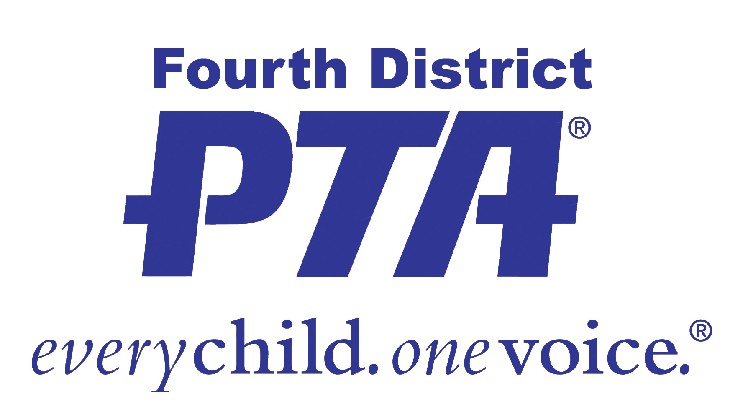 **Fall 2015 PTA Workshops**

**DATE: Tuesday, September 15th**

**LOCATION: National University, 3390 Harbor Blvd., Costa Mesa**

**COST: Early Registration Fee: $10 PER PERSON (no refunds)**

**Early Registration Deadline: FRIDAY, September 4th**

*Fourth District PTA must receive your registration form and payment on or before this date to be eligible for the early registration fee. Please allow time, if mailing.*

**All Late Registrations or at the door payments: $20 per person**

*Walk-in registrations will be accepted only if there is space. Handouts are not guaranteed.*

Note: You may attend sessions in the morning and in the evening for the same fee.

**REGISTRATION PROCEDURES**

1. **Online at** [**www.fourthdistrictpta.org**](http://www.fourthdistrictpta.org)**. *Payment must be made with a credit card. Payments may be made via PayPal.***
2. **Print and mail or deliver the completed form with your payment to:**

**Fourth District PTA, 1520 Brookhollow Drive, #40, Santa Ana, CA 92705**

**714-241-0495 * Hours: Monday-Thursday 9:30 to 2:00 * Email:** [**fourthdistrictpta@sbcglobal.net**](mailto:fourthdistrictpta@sbcglobal.net)

Please complete one form for each person attending the workshops.

**Help us avoid errors and print clearly!**

**First Name: Last Name: Phone Number:**

**________________________ ________ ________________________________ ______________________________**

**Email Address: Your Unit/School: Your PTA Council:**

**________________________________ ________________________________ ______________________________**

**Payment will be made ☐ online with credit card ☐ mailed cash or check (No refunds.)**

**Fees are per person. Please select all of the workshops that you plan to attend.**

**MORNING SESSION EVENING SESSION**

☐ 9:30 to 12:30 President/EVP ☐ 6:00 to 9:00 President/EVP

☐ 9:30 to 12:30 General Financial ☐ 6:00 to 9:00 General Financial

☐ 9:30 to 11:30 Membership ☐ 6:00 to 8:00 Membership

☐ 9:30 to 11:30 Reflections ☐ 6:00 to 8:00 Auditor

☐ 9:30 to 11:30 Parliamentarian ☐ 6:00 to 8:00 Parliamentarian

☐ 9:30 to 11:30 Auditor ☐ 6:00 to 7:00 Secretary

☐ 9:30 to 10:30 Secretary ☐ 7:30 to 8:30 Historian

☐ 11:00 to 12:00 Historian

**ADVOCACY TRAINING**

FREE beginning & advanced advocacy training workshops

**9:15 am - Noon**

**Friday, Sept. 25, 2015**

**National University**

Register at: [www.fourthdistrictpta.org](http://www.fourthdistrictpta.org)

**IN SPANISH – MORNING ONLY**

☐ 9:30 to 12:30 President ☐ 9:30 to 12:30 General Financial

☐ 9:30 to 11:30 Membership ☐ 11:30 to 12:30 Secretary

*Your registration and payment must be in Fourth District Office by 2:00PM on Thursday, September 4th to be eligible for the early registration fee. The fee will be $20 per person for all registrations after September 4th.**No childcare will be provided. Questions: Call 714-241-0495*