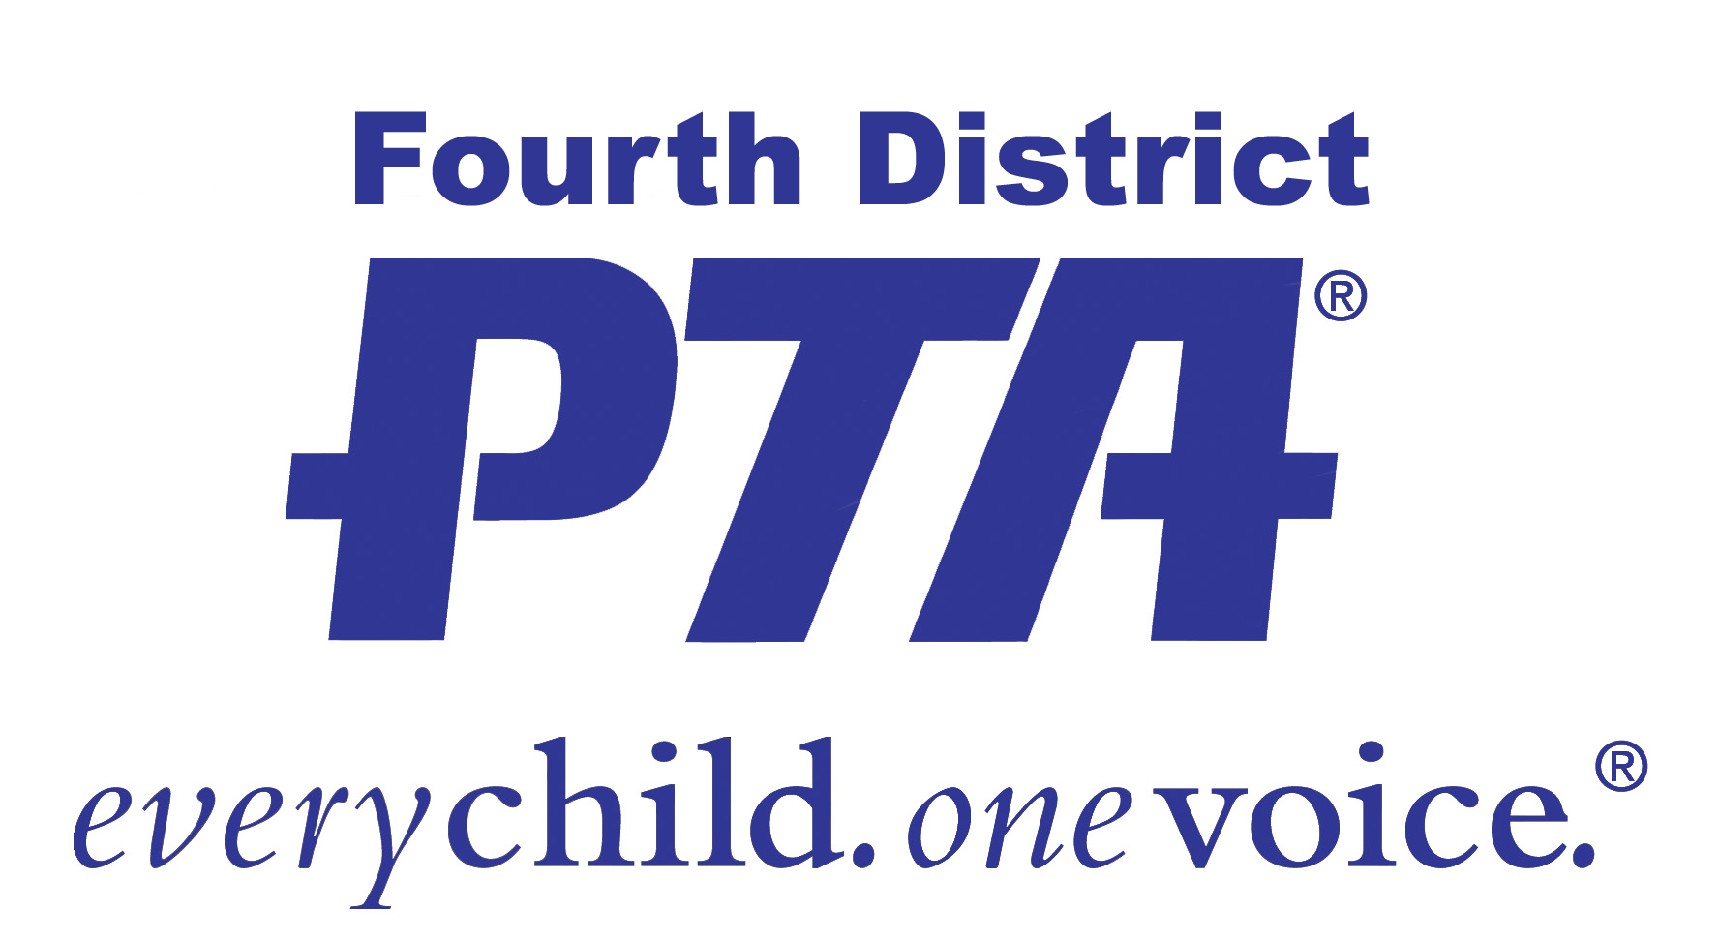**Fourth District PTA

Spring 2015 Workshops

Each workshop will be offered on two days and at two times! Sessions that are offered in the morning on the first date will be offered in the evening on the second date and vice versa. Each person only pays once!

Space is limited so please register for only those sessions you will be able to attend.

**DATES: Tuesday, May 12 and Wednesday, May 20 2015**

**LOCATION: National University, 3390 Harbor Blvd., Costa Mesa**

**COST: Early Registration Fee: $10 PER PERSON (no refunds)**

**Early Registration Deadline: Wednesday, MAY 6th**

*Fourth District PTA must receive your registration form and payment on or before this date to be eligible for the early registration fee. Please allow time, if mailing.*

**All Late Registrations (after May 6) or at the door payments: $20 per person**

*Walk-in registrations will be accepted only if there is space. Handouts are not guaranteed.*

**CLASSES:**

President/EVP

Secretary

Parliamentarian

General Financial

Membership

Auditor

Reflections/ Arts Ed

In Spanish – Presidents

In Spanish – Financial

In Spanish – Membership

In Spanish - Secretary

Historian

Anti- Bullying/Cyber Bullying Awareness

Note: You may attend sessions in the morning and in the evening on one or both days for the same fee. There is no additional cost to attend a workshop on the second day.

**REGISTRATION OPTIONS**

1. **Online (PREFERRED OPTION) at** [**www.fourthdistrictpta.org**](http://www.fourthdistrictpta.org)**.**

***Payment must be made online through PayPal using your personal PayPal account or credit card.***

1. **Registration Form: Print and mail or deliver the completed form (one form per person) with your cash or check payment to:**

**Fourth District PTA**

**1520 Brookhollow Drive, #40**

**Santa Ana, CA 92705**

**Office Phone: 714-241-0495**

**Hours: Monday-Thursday 9:30 to 2:00**

**Email:**[**fourthdistrictpta@sbcglobal.net**](mailto:fourthdistrictpta@sbcglobal.net)

Registration Form: Spring 2014 PTA Workshops

***Please complete one form for each person attending the workshops.***

***Help us avoid errors and print clearly!***

|  |  |
| --- | --- |
| **Name:** | |
| **Email:** | **Phone:** |
| **PTA Unit/School:** | **PTA Council:** |

**Payment per person: $10 until 2 pm, May 6th $20 after May 6th (No refunds.)**

**(Note: A single check can pay for multiple registrations, but use a separate form for each person.)**

**Check made out to “Fourth District PTA” for $____ enclosed.**

**Please select all of the workshops that you plan to attend.**

**TUESDAY, MAY 12TH**

**MORNING SESSION EVENING SESSION**

**☐9:30 to 12:30 President/EVP ☐6:00 to 9:00 General Financial**

**☐9:30 to 11:30 Parliamentarian ☐6:00 to 8:00 Membership**

**☐9:30 to 11:30 Anti-Bullying/Cyber Bullying Awareness ☐6:00 to 8:00 Reflections/ Arts Ed**

**☐9:30 to 10:45 Secretary ☐6:00 to 8:00 Auditor**

**☐11:00 to 12:15 Historian**

*The fee will be $20 per person for all registrations*

*received after 2 pm on May 6th.*

*No Childcare will be provided*

*Questions: Call 714-241-0495*

**In Spanish – Morning Only**

**☐9:30 to 12:30 Presidents**

**☐9:30 to 12:30 Financial**

**☐9:30 to 10:30 Secretary**

**☐10:30 to 12:30 Membership**

**WEDNESDAY, MAY 20TH**

**MORNING SESSION EVENING SESSION**

**☐9:30 to 12:30 General Financial ☐6:00 to 9:00 President/EVP**

**☐9:30 to 11:30 Membership ☐6:00 to 8:00 Anti- Bullying/ Cyber Bullying**

**☐9:30 to 11:30 Reflections/ Arts Ed ☐6:00 to 8:00 Parliamentarian**

**☐9:30 to 11:30 Auditor ☐6:00 to 7:15 Secretary**

**☐7:30 to 8:45 Historian**

**In Spanish – Morning Only**

**☐9:30 to 11:30 Presidents Mail completed form and payment to:**

**☐9:30 to 11:30 Financial Fourth District PTA / Workshops**

**☐9:30 to 10:30 Secretary 520 Brookhollow Drive, #40**

**☐10:30 to 12:30 Membership Santa Ana, CA 92705**